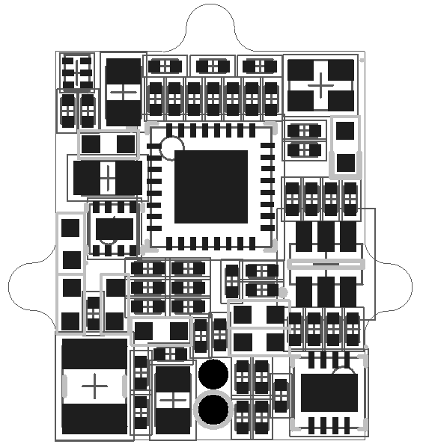**CMOS Imaging Sensor Circuit Board Assembly Information**

* Top layer component descriptors: Mechanical layer 5
* Bottom layer component descriptors: Mechanical layer 6
* Double sided assembly: Yes
* Pin 1 identifiers on Mechanical Layers 5 (GM5) and 6 (GM6)
  + Top: GM5
  + Bottom: GM6
* 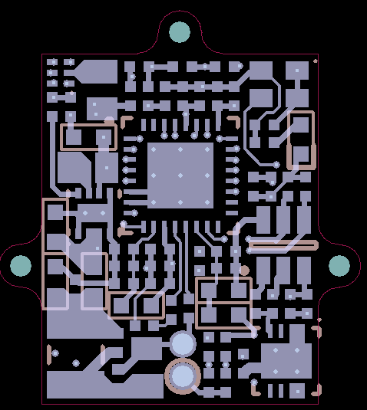D1 (LED) orientation shown below

